SMART DOOR LOCK SYSTEM

## A MINI-PROJECT REPORT

***Submitted by***

|  |  |
| --- | --- |
| **SIVAROOBAN V** | **210701251** |
| **SHRIRAM** | **210701248** |

***in partial fulfillment of the award of the degree of***

# BACHELOR OF ENGINEERING

**IN**

**COMPUTER SCIENCE ENGINEERING**



# RAJALAKSHMI ENGINEERING COLLEGE, ANNA UNIVERSITY: CHENNAI 600 025

## MAY 2024

**BONAFIDE CERTIFICATE**

Certified that this Report titled “**SMART DOOR LOCK SYSTEM**” is the bonafide work of **SIVAROOBAN V (210701251),SHRIRAM S (210701248)** who carried out the work under my supervision. Certified further that to the best of my knowledge the work reported herein does not form part of any other thesis or dissertation on the basis of which a degree or award was conferred on an earlier occasion on this or any other candidate.

**SIGNATURE**

Mr.S.Suresh Kumar M.E.,(PhD.),

**SUPERVISOR**

Professor

Department of Computer Science and Engineering

Rajalakshmi Engineering College Chennai - 602 105

Submitted to Project Viva-Voce Examination held on

**INTERNAL EXAMINER EXTERNAL EXAMINER**

## ABSTRACT

This project outlines a smart door lock system leveraging an Arduino Uno, an MFRC522 RFID reader, and a solenoid lock controlled by a relay module. Powered by a 12V battery, the system uses LEDs and a buzzer for user feedback. The RFID reader authenticates users by comparing RFID tag UIDs against a list of authorized UIDs. Upon successful authentication, the Arduino triggers the relay to unlock the solenoid lock, indicated by a green LED and a buzzer beep. Unauthorized attempts activate a red LED and a longer buzzer sound. This setup provides a secure, user-friendly access control solution, suitable for both residential and commercial applications. The modular design allows for easy customization and scalability, showcasing the practicality of Arduino-based automation in enhancing security systems.

## ACKNOWLEDGEMENT

Initially we thank the Almighty for being with us through every walk of our life and showering his blessings through the endeavour to put forth this report. Our sincere thanks to our Chairman **Mr. S.MEGANATHAN, B.E, F.I.E.**, our Vice Chairman **Mr. ABHAY SHANKAR MEGANATHAN, B.E., M.S.,** and

our respected Chairperson **Dr. (Mrs.) THANGAM MEGANATHAN**, **Ph.D.,** for providing us with the requisite infrastructure and sincere endeavouring in educating us in their premier institution.

Our sincere thanks to **Dr. S.N. MURUGESAN, M.E., Ph.D.,** our beloved Principal for his kind support and facilities provided to complete our work in time. We express our sincere thanks to **Dr.P.KUMAR, Ph.D.**, Professor and Head of the Department of Computer Science and Engineering for his guidance and encouragement throughout the project work. We convey our sincere and deepest gratitude to our internal guide, **Mr.S. SURESH KUMAR M.E.,(Ph.D.),** Department of Computer Science and Engineering, Rajalakshmi Engineering College for his valuable guidance throughout the course of the project.

**SIVAROOBAN V 210701251 SHRIRAM S 210701248**

**TABLE OF CONTENTS**

|  |  |  |
| --- | --- | --- |
| **CHAPTER NO** | **TITLE** | **PAGE NO** |
| **1** | **INTRODUCTION** | 1 |
| **2** | **LITERATURE SURVEY** | 2 |
| 2.1 | EXISTING SYSTEM | 3 |
| **3** | **PROJECT DESCRIPTION** | 4 |
| 3.1 | PROPOSED SYSTEM | 6 |
| 3.2 | REQUIREMENTS | 6 |
| 3.2.1 | HARDWARE REQUIREMENTS | 6 |
| 3.2.2 | SOFTWARE REQUIREMENTS | 6 |
| 3.3 | ARCHITECTURE DIAGRAM | 7 |
| 3.4 | OUTPUT | 8 |
| **4** | **CONCLUSION AND FUTURE WORK** | 11 |
|  | **APPENDICES** | 12 |
|  | **REFERENCE** | 14 |

# CHAPTER 1 INTRODUCTION

The need for enhanced security and convenience in access control systems has led to the development of various smart technologies. This project focuses on creating a smart door lock system utilizing an Arduino Uno, MFRC522 RFID reader, solenoid lock, relay module, and a 12V battery. Traditional locks, while effective, often fall short in providing the flexibility and remote management required in modern settings. RFID technology offers a robust solution by enabling contactless authentication and seamless integration with electronic control systems.

The core of this system lies in its ability to read and verify RFID tags/cards through the MFRC522 reader. The Arduino Uno processes the unique identifiers (UIDs) of these tags and determines access rights based on predefined authorization. Upon successful authentication, the system activates the solenoid lock via a relay, allowing the door to unlock. User feedback is enhanced through visual indicators using LEDs and auditory signals from a buzzer, making the system intuitive and user-friendly.

This project not only provides a practical and secure method for access control but also demonstrates the versatility and potential of Arduino-based systems in automating everyday tasks. By integrating common electronic components, this smart door lock system offers a scalable and customizable solution suitable for residential, commercial, and institutional applications.

# CHAPTER 2 LITERATURE SURVEY

The rapid advancement in technology has significantly influenced the development of security systems, with smart door lock systems becoming a crucial component of modern security solutions. This literature survey delves into the integration of RFID technology with microcontroller-based systems, specifically focusing on the Arduino platform, to create effective and user-friendly smart door locks. RFID (Radio Frequency Identification) technology is widely used in access control systems due to its contactless nature and reliability. RFID systems consist of tags, readers, and a backend database for verification. According to Finkenzeller (2010), RFID tags, embedded with unique identifiers (UIDs), enable secure and quick identification, making them ideal for access control applications. Microcontroller-based solutions, particularly those utilizing Arduino, have gained popularity due to their simplicity, affordability, and versatility. Banzi and Shiloh (2014) describe how Arduino can be employed to prototype various electronic projects, including security systems, due to its open-source platform and extensive community support. Numerous studies have demonstrated the effectiveness of combining RFID technology with Arduino to enhance security. Rashid and Rehmani (2016) highlighted that using Arduino for smart door locks provides a cost-effective and customizable solution that can be tailored to specific security needs. Research by Rahman et al. (2017) showcased an RFID-based door lock system using Arduino, demonstrating the simplicity of the setup and its efficacy in providing secure access. The system efficiently controlled access by verifying RFID tags and activating locking mechanisms, proving its reliability in real-world applications. Solenoid locks are often employed in these systems due to their robustness and ability to withstand frequent use.

To interface the low-power Arduino with the high-power solenoid lock, a relay module is typically used. Al-Maadeed et al. (2017) provide insights into using relays and solenoid locks in security systems, emphasizing their effectiveness in electronically controlling physical access. The integration of user feedback mechanisms such as LEDs and buzzers further enhances the user experience by providing clear visual and auditory signals of the system's status. Yuan et al. (2018) noted that incorporating LEDs and buzzers significantly improves the usability of security systems, making it easier for users to understand access statuses and system responses. This combination of RFID, Arduino, solenoid locks, and feedback mechanisms creates a comprehensive and efficient access control solution. The modular design of Arduino-based systems allows for easy customization and scalability, enabling the addition of features such as remote access or integration with other security systems. In summary, the literature underscores the effectiveness of combining RFID technology with Arduino microcontrollers to create smart door lock systems. These systems offer secure, convenient, and cost-effective access control solutions suitable for various applications, from residential to commercial settings. This project builds upon these foundational studies and technologies to develop a practical, scalable, and user-friendly smart door lock system, leveraging the strengths of RFID for secure identification, Arduino for flexible control, and solenoid locks for reliable physical security. The comprehensive approach ensures a robust solution that meets modern security needs while remaining accessible and adaptable for future enhancements.

# EXISTING SYSTEM

# The existing door lock systems encompass mechanical, electronic, and smart locks. Mechanical locks, relying on physical keys, lack remote access and are vulnerable to key-related issues. Electronic locks offer keyless entry through numeric keypads or cards, enhancing security and convenience. However, they remain susceptible to electronic failures and hacking. Smart locks, the latest innovation, integrate advanced technologies like RFID, Bluetooth, or Wi-Fi for keyless entry, remote access, and monitoring via smartphone apps or home automation systems. They provide heightened security, user convenience, and flexibility, allowing users to grant temporary access to visitors remotely. Despite their advantages, smart locks may still face cybersecurity risks and compatibility issues with existing infrastructure, necessitating careful consideration during implementation and adoption.

# CHAPTER 3 PROJECT DESCRIPTION

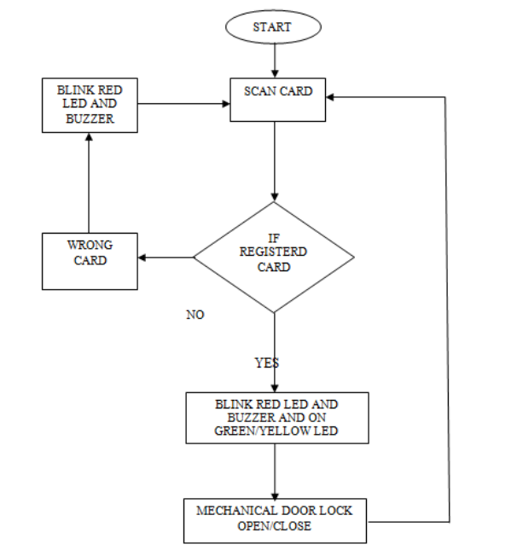

The smart door lock system proposed in this project aims to provide a secure, convenient, and user-friendly solution for access control. Leveraging RFID technology, an Arduino Uno microcontroller, a solenoid lock, a relay module, and additional components, the system offers keyless entry and remote access capabilities.

**Functionality:**

RFID Authentication: Users gain access by presenting RFID tags or cards to the MFRC522 RFID reader.

**Authorization:** The system verifies the unique identifiers (UIDs) of the RFID tags/cards against a pre-defined list of authorized UIDs stored in the Arduino's memory.

**Lock Control:** Upon successful authentication, the Arduino triggers the relay module to activate the solenoid lock, unlocking the door.

**User Feedback:** LEDs and a buzzer provide visual and auditory feedback, indicating access status (granted/denied) to the user.

**Remote Access (Optional):** The system can be extended to incorporate remote access capabilities, allowing users to control the lock remotely via a smartphone app or web interface.

**Software Development:** Write the Arduino code to initialize the RFID reader, authenticate users, control the relay module, and provide feedback through LEDs and the buzzer.

**Testing and Calibration:** Test the system's functionality by presenting authorized and unauthorized RFID tags/cards to the reader, observing the lock's response and feedback indicators.

**Optional Enhancements:** Implement additional features such as remote access via a smartphone app, user management functionalities, or integration with home automation systems.

**Benefits:**

* Enhanced Security: Keyless entry and RFID authentication provide robust security against unauthorized access.
* User Convenience: Eliminates the need for physical keys and offers a seamless access experience.
* Remote Access: Optional remote access capabilities add flexibility and convenience for users to control access from anywhere.

## PROPOSED SYSTEM

The proposed smart door lock system integrates RFID-based authentication, microcontroller control, and user-friendly features to enhance security, convenience, and flexibility in access control. Utilizing an Arduino Uno as the main controller and an MFRC522 RFID reader for authentication, the system verifies user identities through RFID tags or cards. LEDs and a buzzer provide instant feedback on access status, while optional remote access capabilities enable users to manage access remotely via smartphone or web interface. With centralized access control and real-time monitoring, the system offers administrators the ability to manage access privileges and track access events efficiently. Overall, the proposed system aims to provide a comprehensive and user-friendly solution for modern security needs.

## REQUIREMENTS

### HARDWARE REQUIREMENTS

* Arduino Uno
* MFRC522 RFID Reader
* Solenoid Lock
* Relay Module
* LEDs
* Buzzer
* 12V Battery/Power Supply

### SOFTWARE REQUIREMENTS

* Arduino IDE
* MFRC522 Library
* Additional Libraries

## ARCHITECTURE DIAGRAM

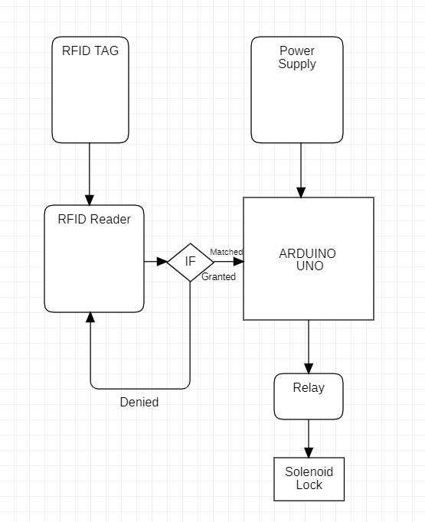

### Figure 2

This diagram illustrates the basic components and their interactions in the system. The user interface interacts with the Arduino Uno, which serves as the main controller. The Arduino communicates with the MFRC522 RFID reader to authenticate users by reading RFID tags/cards. Upon successful authentication, the Arduino triggers the solenoid lock to grant access. Additional components such as LEDs and a buzzer may provide feedback to users regarding access status.

## OUTPUT

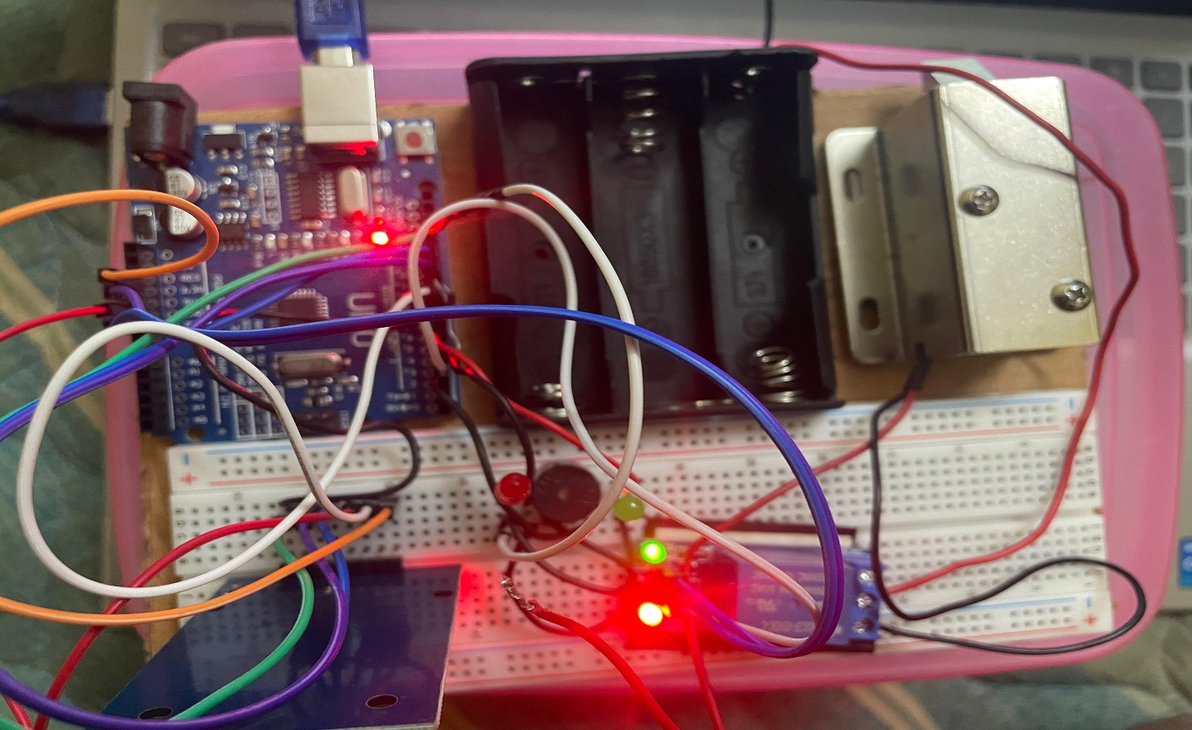

### Figure 3

### Figure 3

Figure 3 ,3.1is the output of real time updation of the scanned RFID tag

Figure 3 ,3.1is the output of real time updation of the scanned RFID tag along with student id, status as in in or out and the timeline with date and time.

### CONNECTIONS:

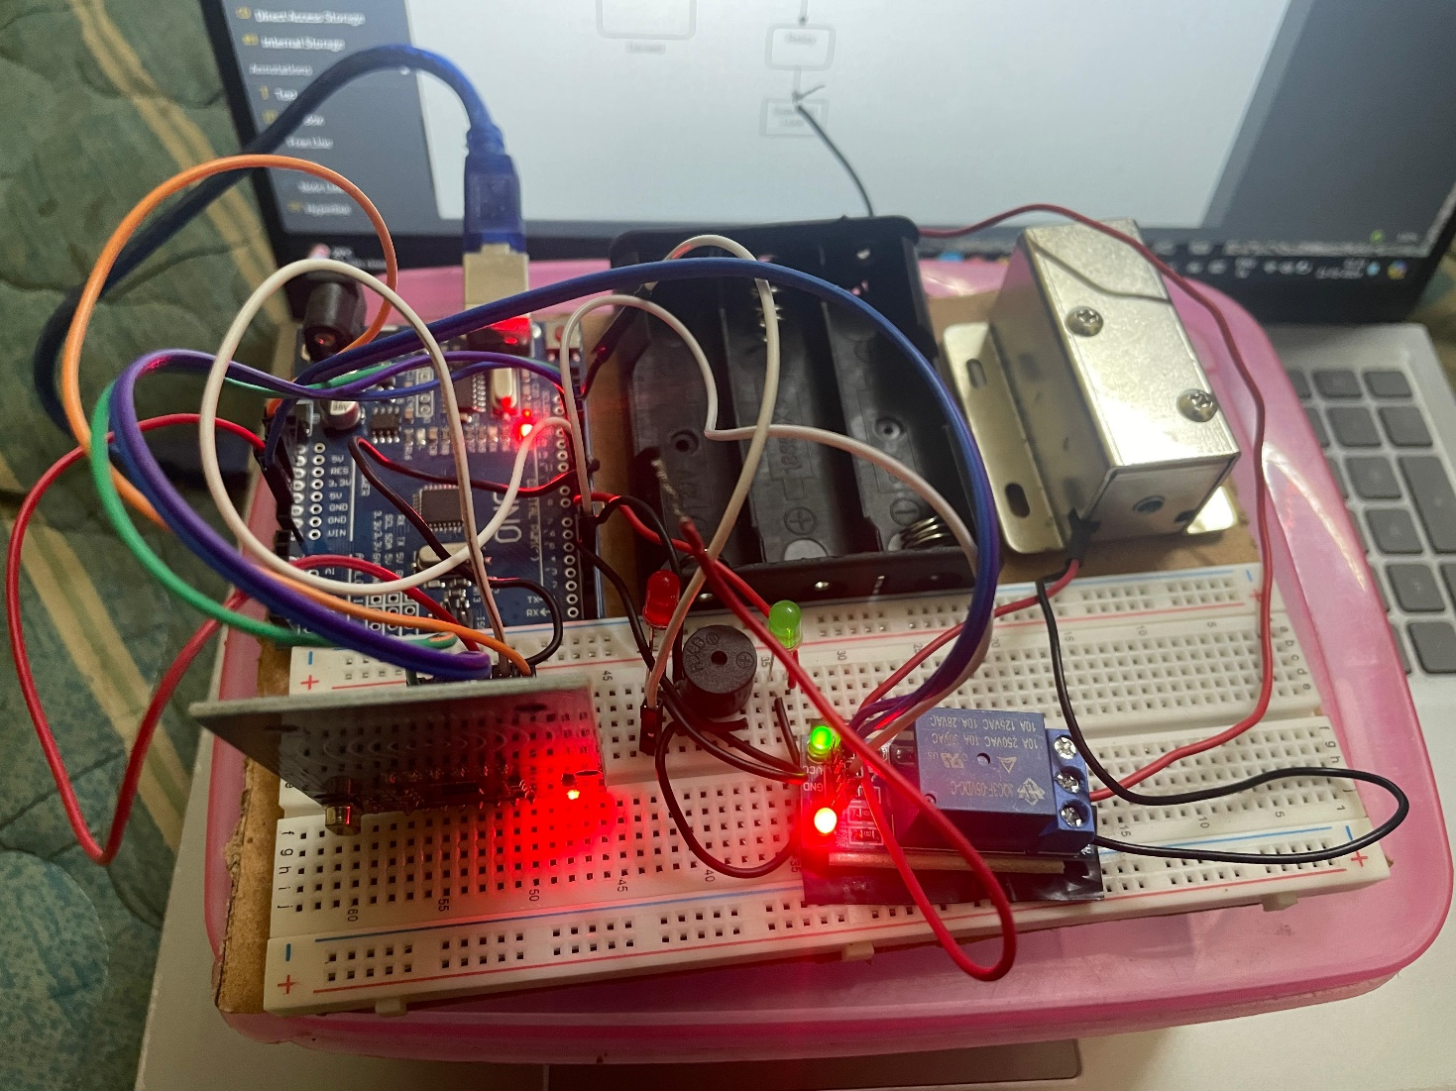

**Figure 4**

Figure 4 shows the connections made to the RFID to interface with the Arduino. The connections are provided as specified in the architecture.

## CHAPTER 4 CONCLUSION AND FUTURE WORK

In conclusion, the development of the smart door lock system using Arduino Uno and RFID technology presents a significant advancement in access control solutions. By leveraging RFID authentication and microcontroller control, the system provides enhanced security, convenience, and flexibility for users. Through the integration of user-friendly features such as LEDs and a buzzer, the system offers intuitive feedback on access status, ensuring ease of use for all users. The proposed system demonstrates the effectiveness of combining advanced technology with practical applications to address modern security needs in residential, commercial, and institutional settings.

**Remote Access and Monitoring:** Implementing remote access capabilities via smartphone apps or web interfaces would allow users to control and monitor the system from anywhere, enhancing convenience and security.

**Biometric Authentication:** Integrating biometric authentication methods such as fingerprint or facial recognition would offer an additional layer of security and convenience for users.

**Integration with Home Automation Systems:** Integrating the smart door lock system with existing home automation platforms such as Alexa or Google Home would enable seamless integration with other smart devices and enhance overall home security and automation.

**APPENDIX I**

#include <SPI.h>

#include <MFRC522.h>

#define SS_PIN 10

#define RST_PIN 9

#define LED_G 5 //define green LED pin

#define LED_R 4 //define red LED

#define RELAY 3 //relay pin

#define BUZZER 2 //buzzer pin

#define ACCESS_DELAY 2000

#define DENIED_DELAY 1000

MFRC522 mfrc522(SS_PIN, RST_PIN); // Create MFRC522 instance.

void setup()

{

Serial.begin(9600); // Initiate a serial communication

SPI.begin(); // Initiate SPI bus

mfrc522.PCD_Init(); // Initiate MFRC522

pinMode(LED_G, OUTPUT);

pinMode(LED_R, OUTPUT);

pinMode(RELAY, OUTPUT);

pinMode(BUZZER, OUTPUT);

noTone(BUZZER);

digitalWrite(RELAY, LOW);

Serial.println("Put your card to the reader...");

Serial.println();

}

void loop()

{

// Look for new cards

if ( ! mfrc522.PICC_IsNewCardPresent())

{

return;

}

// Select one of the cards

if ( ! mfrc522.PICC_ReadCardSerial())

{

return;

}

//Show UID on serial monitor

Serial.print("UID tag :");

String content= "";

byte letter;

for (byte i = 0; i < mfrc522.uid.size; i++)

{

Serial.print(mfrc522.uid.uidByte[i] < 0x10 ? " 0" : " ");

Serial.print(mfrc522.uid.uidByte[i], HEX);

content.concat(String(mfrc522.uid.uidByte[i] < 0x10 ? " 0" : " "));

content.concat(String(mfrc522.uid.uidByte[i], HEX));

}

Serial.println();

Serial.print("Message : ");

content.toUpperCase();

if (content.substring(1) == "A0 81 15 12") //change here the UID of the card/cards that you want to give access

{

Serial.println("Authorized access");

Serial.println();

delay(500);

digitalWrite(RELAY, HIGH);

digitalWrite(LED_G, HIGH);

delay(ACCESS_DELAY);

digitalWrite(RELAY, LOW);

digitalWrite(LED_G, LOW);

}

else {

Serial.println(" Access denied");

digitalWrite(LED_R, HIGH);

tone(BUZZER, 300);

delay(DENIED_DELAY);

digitalWrite(LED_R, LOW);

noTone(BUZZER);

}

}

**REFERENCE**

1. Ketan Rathod, Rambabu Vatti, Mandar Nandre and Sanket Yenare, "Smart door security using Arduino and Bluetooth application", *International Journal of Current Engineering and Scientific Research*, vol. 4, no. 11, pp. 73-77, 2017.
2. Lubhansh Kumar Bhute, Gagandeep Singh, Avinash Singh, Vikram Kansary, Preetam Rao Kale and Shailendra Singh, "Automatic Door Locking System Using Bluetooth Module", *International Journal for Research in Applied Science & Engineering Technology*, vol. 5, no. 05, pp. 1128-1131, 2017.
3. NishadN. Gupte and Mihir R. Shelar, "Smart Door Locking System", *International Journal of Engineering Research & Technology*, vol. 2, no. 11, pp. 2214-2217, 2013.
4. Rahul Satoskar and Akarsh Mishrac, "Smart Door Lock and Lighting System using Internet of Things", *International Journal of Computer Science and Information Technologies*, vol. 9, no. 05, pp. 132-135, 2018.
5. O. Agbo David, Madukwe Chinaza and O. OdinyaJotham, "Design And Implementation Of A Door Locking System Using Android App", *International Journal Of Scientific & Technology Research*, vol. 6, no. 08, pp. 198-203, 2017.
6. Hashem Alnabhi, Yahya Al-naamani, Mohammed Al-madhehagi and Mohammed Alhamzi, "Enhanced Security Methods of Door Locking Based Fingerprint", *International Journal of Innovative Technology and Exploring Engineering*, vol. 9, no. 03, pp. 1173-1178, 2020.
7. Shahid Sohail, Sajid Prawez and C.K. Raina, "A Digital Door Lock System For The Internet Of Things With Improved Security And Usability", *International Journal of Advance Research ldeas and Innovations in Technology*, vol. 4, no. 03, pp. 878-880, 2018.
8. R. Das and G. Tuna, "Packet tracing andanalvsis of network cameras with Wireshark", *5th International Symposium on Digital Forensic and Security(ISDFS)*, 2017.
9. Haroon Iqball and Sameena Naaz, "Wireshark as a Tool for Detection of Various LAN Attacks", *International Journal of Computer Science and Engineering*, vol. 7, no. 05, pp. 833-837, 2019.
10. Chunnu Khawas and Pritam Shah, "Application of firebase in Android App Development - A Studv", *International Journal of Computer Applications*, vol. 179, no. 46, pp. 49-53, 2018.
11. D. Sivaganesan, "Design And Development Ai-Enabled Edge Computing For Intelligent-Iot Application", *Journal of trends in Computer Science and Smart technology (TCSST)*, vol. 1, no. 02, pp. 84-94, 2019.
12. J. S. Raj and J. V. Ananthi, "Automation using IoT in greenhouse environment", *Journal oflnformation Technology*, vol. 1, no. 01, pp. 38-47, 2019.